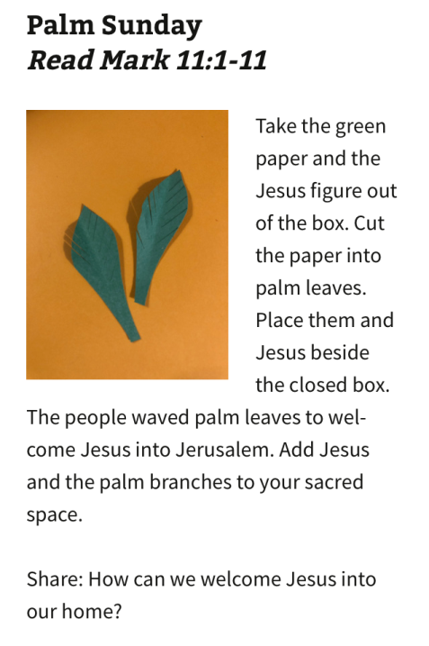Creating a sacred space at home: Using resources from rowsofsharon.com (I’m not using a box!! )

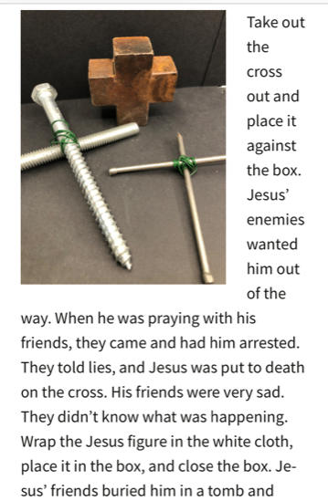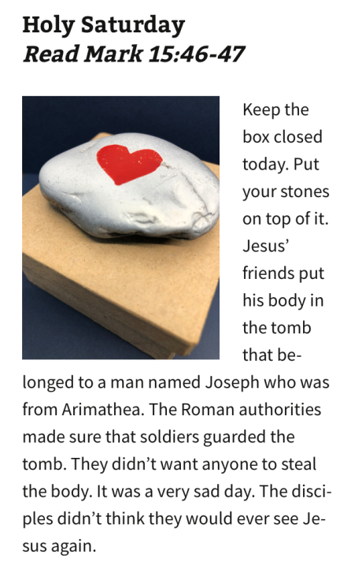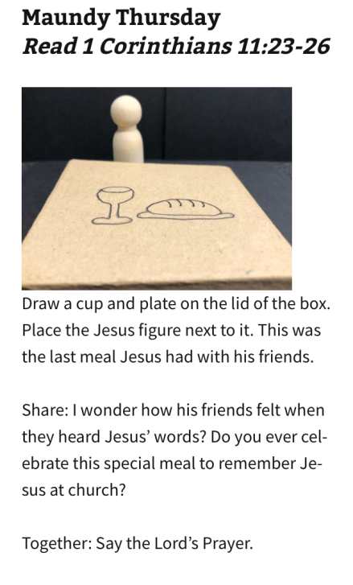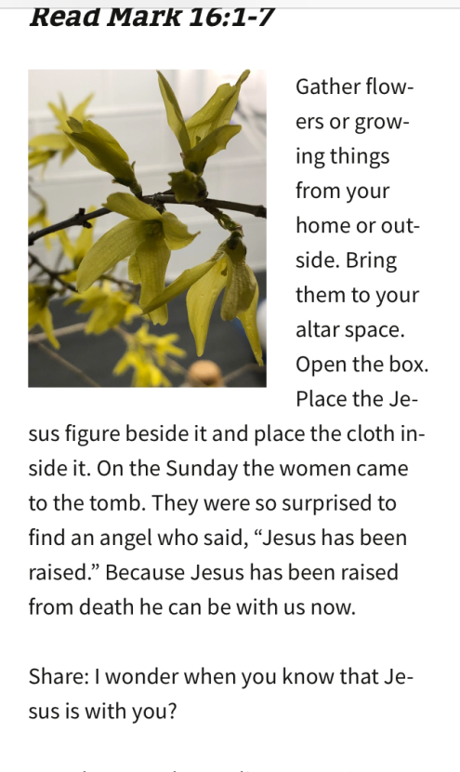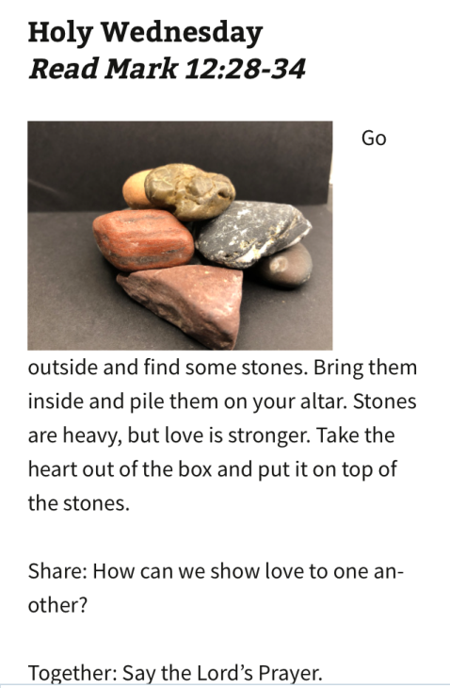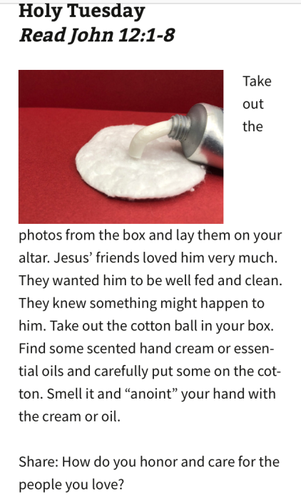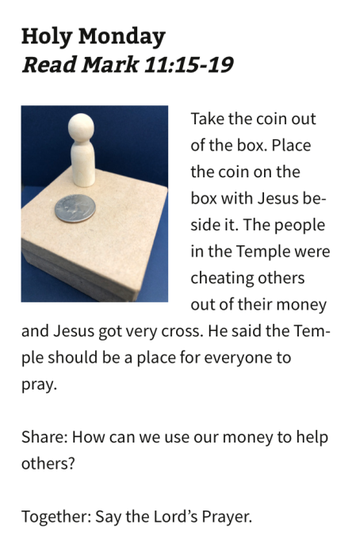

Share: When you are sad, what do you do to make yourself feel better?

Together: Say the Lord’s Prayer

Wondered what would happen next

Share: I wonder what it might be like not to have Jesus with us.

Together: Say the Lord’s Prayer

**Good Friday**: Read Mark 15;1,15,22-25,33-34,39-46